 

## A Minor Project II Report on

**ARDUINO BASED ROTATING SOLAR PANEL**

## Submitted by

**NALIN KUMAR S P (927622BEE073)**

## SANJAAI U N (927622BEE094)

## SHARMITHA S P (927622BEE106)



**DEPARTMENT OF ELECTRICAL AND ELECTRONICS ENGINEERING M.KUMARASAMY COLLEGE OF ENGINEERING**

(An Autonomous Institution Affiliated to Anna University, Chennai) THALAVAPALAYAM, KARUR-639113.

## DECEMBER 2023

M.KUMARASAMY COLLEGE Of ENGINEERING

(Autonomous Institution, Affiliated to Anna University, Chennai)

# BONAFIDE CERTIFICATE

Certified that this Report titled **“ARDUINO BASED ROTATING SOLAR PANEL”** is the Bonafide work of **NALIN KUMAR S P (927622BEE073), SANJAAI U N (927622BEE094), SHARMITHA S P (927622BEE106)** who carried out the work during the academic year (2023-2024) under my supervision. Certified further that to the best of my knowledge the work reported herein does not form part of any other project report.

**SIGNATURE SIGNATURE**

**SUPERVISOR HEAD OF THE DEPARTMENT**

Mr.N.Selvam M.E., Dr.J.Uma M.E., Ph.D.,

Assistant Professor Professor & Head

Department of Electrical and Electronics Engineering

M.Kumarasamy College of

Engineering, Karur.

Department of Electrical and Electronics Engineering

M.Kumarasamy College of

Engineering, Karur.

Submitted for Minor Project II (18EEP202L) viva-voce Examination held at M Kumarasamy College of Engineering, Karur-639113 on ………………...

## DECLARATION

We affirm that the Minor Project I report titled “**ARDUINO BASED ROTATING SOLAR PANEL”** being submitted in partial fulfillment for the award of **Bachelor of Engineering in Electrical and Electronics Engineering** is the original work carried out by us.

|  |  |  |
| --- | --- | --- |
| REG.NO | STUDENT NAME | SIGNATURE |
| 927622BEE073 | **NALIN KUMAR S P** | ----------------------- |
| 927622BEE094 | **SANJAAI U N** | ----------------------- |
| 927622BEE106 | SHARMITHA S P | ----------------------- |

|  |
| --- |
|  |

### VISION AND MISSION OF THE INSTITUTION

**VISION**

* To emerge as a leader among the top institutions in the field of technical education

### MISSION

* Produce smart technocrats with empirical knowledge who can surmount the global Challenges.
* Create a diverse, fully engaged, learner - centric campus environment to provide Quality education to the students.
* Maintain mutually beneficial partnerships with our alumni, industry and Professional associations.

### DEPARTMENT OF ELECTRICAL AND ELECTRONICS ENGINEERING VISION

To produce smart and dynamic professionals with profound theoretical and practical knowledge comparable with the best in the field.

### MISSION

* Produce hi-tech professionals in the field of Electrical and Electronics Engineering by inculcating core knowledge.
* Produce highly competent professionals with thrust on research.
* Provide personalized training to the students for enriching their skills.

### PROGRAMME EDUCATIONAL OBJECTIVES(PEOs)

* **PEO1:** Graduates will have flourishing career in the core areas of Electrical Engineering and allied disciplines.
* **PEO2:** Graduates will pursue higher studies and succeed in academic/research careers.
* **PEO3:** Graduates will be a successful entrepreneur in creating jobs related to Electrical and Electronics Engineering /allied disciplines.
* **PEO4:** Graduates will practice ethics and have habit of continuous learning for their success in the chosen career.

**PROGRAMME OUTCOMES(POs)**

After the successful completion of the B.E. Electrical and Electronics Engineering degree program, the students will be able to:

**PO1: Engineering Knowledge:** Apply the knowledge of mathematics, science, engineering fundamentals, and an engineering specialization to the solution of complex engineering problems.

**PO2: Problem Analysis:** Identify, formulate, review research literature, and analyze complex engineering problems reaching substantiated conclusions using first principles of mathematics, natural sciences, and engineering sciences.

**PO3: Design/Development of solutions:**

Design solutions for Complex engineering problems and design system components or processes that meet the specified needs with appropriate consideration for the public health and safety, and the cultural, societal, and environmental considerations.

**PO4: Conduct Investigations of complex problems:** Use research-based knowledge and research methods including design of experiments, analysis and interpretation of data, and synthesis of the information to provide valid conclusions.

**PO5: Modern Tool Usage:** Create, select, and apply appropriate techniques, resources, and modern engineering and IT tools including prediction and modeling to complex engineering activities with an understanding of the limitations.

**PO6: The Engineer and Society:** Apply reasoning in formed by the contextual knowledge to assess societal, health, safety, legal and cultural issues and the consequent responsibilities relevant to the professional engineering practice.

**PO7: Environment and Sustainability:** Understand the impact of the professional engineering solutions in societal and environmental contexts, and demonstrate the knowledge of, and need for sustainable development.

**PO8: Ethics:** Apply ethical principles and commit to professional ethics and responsibilities and norms of the engineering practice.

**PO9: Individual and Teamwork:** Function effectively as an individual, and as a member or leader in diverse teams, and in multi-disciplinary settings.

**PO10: Communication:** Communicate effectively on complex engineering activities with the engineering community and with society at large, such as, being able to comprehend and write effective reports and design documentation, make effective presentations, and give and receive clear instructions.

**PO11: Project Management and Finance:** Demonstrate knowledge and understanding of the engineering and management principles and apply these to one’s own work, as a member and leader in a team, to manage projects and in multi-disciplinary environments.

**PO12: Life-long learning:** Recognize the need for and have the preparation and ability to engage in independent and life-long learning in the broadest context of technological change.

### PROGRAM SPECIFIC OUTCOMES(PSOs)

The following are the Program Specific Outcomes of Engineering Students:

* **PSO1:** Apply the basic concepts of mathematics and science to analyses and design circuits, controls, Electrical machines and drives to solve complex problems.
* **PSO2:** Apply relevant models, resources and emerging tools and techniques to provide solutions to power and energy related issues & challenges.
* **PSO3:** Design, Develop and implement methods and concepts to facilitate solutions for electrical and electronics engineering related real-world problems.

|  |  |
| --- | --- |
| **Abstract (Key Words)** | **Mapping of POs and PSOs** |
| LDR sensor, Servo motors, Solar panel, Charge controller, Battery. | PO1, PO2, PO3, PO4, PO5, PO6, PO7, PO8, PO9, PO11, PSO1, PSO2, PSO3. |

## [ACKNOWLEDGEMENT](https://www.google.com/search?rlz=1C1CHBD_enIN820IN820&q=ACKNOWLEDGEMENT&spell=1&sa=X&ved=0ahUKEwj99az1_ZXhAhVN63MBHRVODE4QkeECCCkoAA&cshid=1553265789884876)

Our sincere thanks to **Thiru.M.Kumarasamy, Chairman and Dr.K.Ramakrishnan B.E, Secretary** of **M.Kumarasamy College of Engineering** for providing extra ordinary infrastructure, which helped us to complete the Minor project in time.

It is a great privilege for us to express our gratitude to our esteemed **Principal Dr.B.S.Murugan., M.Tech., Ph.D.,** for providing us right ambiance for carrying out the project work.

We would like to thank our **Head of the Department Dr.J.Uma.,M.E., Ph.D., Department of Electrical and Electronics Engineering,** for her unwavering moral support throughout the evolution of the project.

We would like to express my deep gratitude to our Minor Project Guide **Mr.N.Selvam**.,**M.E., Assistant Professor, Department of Electrical and Electronics Engineering,** for his constant encouragement, kind co-operation, valuable suggestions and support rendered in making our project a success.

We offer our wholehearted thanks to our Minor project coordinator **Dr.B.Rajesh Kumar M.E., Ph.D.,**  **Assistant Professor, Department of Electrical and Electronics Engineering,** for his constant encouragement, kind co-operation and valuable suggestions for making our project a success.

We are glad to thank all the **Faculty Members** of **Department of Electrical and Electronics Engineering** for extending a warm helping hand and valuable suggestions throughout the project.

Words are boundless to thank **Our Parents and Friends** for their constant encouragement to complete this Minor project successfully.

**TABLE OF CONTENTS**

|  |  |  |
| --- | --- | --- |
| CHAPTER NO | CONTENTS | PAGE NO |
|  | VISION AND MISSION OF THE INSTITUTION | **IV** |
|  | **VISION AND MISSION OF THE DEPARTMENT** | **IV** |
|  | **PROGRAM OUTCOMES** | **IV** |
|  | **PROGRAM SPECIFIC OUTCOMES** | **V** |
|  | **LIST OF FIGURES** | **IX** |
|  | **LIST OF ABBREVIATIONS** | **X** |
|  | **ABSTRACT** | **XI** |
|  | **SURVEY FORM** | **1** |
| 1 | **SURVEY FORM ANALYSIS**  1.1 Name and Address of the Community  1.2 Problem Identification  1.3 solution | **4**  **4**  **4** |
| 2 | **LITRATURE REVIEW**  2.1 Solar Tracking System  2.2 Dual Axis Solar Tracking System  2.3 Sunflower Type Solar Tracking System  2.4 Automatic Night Light Circuit | **5**  **5**  **6**  **7** |
| 3 | **PROPOSED METHODOLOGY**  3.1 Block Diagram  3.2 Description  3.3 Cost Estimation | **8**  **9**  **13** |
| 4 | **FUTURE SCOPE AND ITS IMPLEMENTATION PLAN** | **14** |
| 5 | **IMPLEMENTATION PHOTOS** | **17** |
| 6 | **REFERENCES** | **19** |

**LIST OF FIGURES**

|  |  |  |
| --- | --- | --- |
| FIGURE NO | TITLE | PAGE NO |
| 3.1 | Block diagram of Arduino based rotating solar panel | 8 |
| 3.2 | LDR Sensor | 10 |
| 3.3 | Servo Motor | 11 |
| 3.4 | Arduino UNO | 11 |
| 3.5 | Solar Panel | 12 |
| 3.6 | LED | 12 |
| 5.1  5.2 | Implementation Photos | 17 |
| 5.3 | Geotags Implementation Photo | 18 |

**LIST OF TABALE**

|  |  |  |
| --- | --- | --- |
| TABLE NO | TITLE | PAGE NO |
| 3.1 | Cost estimation | 13 |

|  |
| --- |
|  |

**LIST OF ABBREVIATION**

|  |  |  |
| --- | --- | --- |
| S.NO | ABBREVIATION | EXPANSION |
| 1 | LDR | Light Dependent Resistor |
| 2 | LCD | Liquid Crystal Display |
| 3 | LED | Light Emitting Diode |
| 4 | IDE | Integrated Development Environment |
| 5 | IOT | Internet of Things |
| 6 | CSP | Concentrated Solar Power |

|  |
| --- |
|  |

**ABSTRACT**

The goal of this was to develop a laboratory prototype of a rotating solar panel with a solar tracking system that is able to enhance the performance of the photovoltaic modules in a solar energy system. The operating principle of the device is to keep the photovoltaic modules constantly aligned with the sunbeams, which maximizes the exposure of the solar panel to the sun’s radiation. As a result, more output power can be produced by the solar panel. The work of the project included hardware design and implementation, together with software programming for the microcontroller unit of the solar tracker. The system utilized an ATmega328P microcontroller to control the motion of two servo motors, which rotate the solar panel in two axes. The amount of rotation was determined by the microcontroller based on inputs retrieved from four photosensors located next to the solar panel.  The solar panel converts the heat energy into electrical energy; the electrical energy is stored in the battery with the help of a charge controller. The automatic streetlamp circuit draws energy from the batteries used for streetlamps. The automatic circuit consists of an LDR sensor and an NPN transistor, and the transistor converts the signal that comes from the LDR to an alternate. If the LDR acts as non-resistance, the transistor does not allow voltage into the circuit. If the LDR becomes resistant, the transistor allows voltage into the circuit. The LDR acts as low resistance during the day and becomes high resistance at night. At the end of the project, a functional Arduino-based rotating solar panel system was designed and implemented. It was able to keep the solar panel aligned with the sun. The design of the Arduino-based rotating solar panel from this project is also a reference and a starting point for the development of more advanced systems in the future.

**Keywords:** LDR sensor, Servo motors, Solar panel, Charge controller, Battery.

**CHAPTER 1**

**SURVEY FORM ANALYSIS**

* 1. **NAME AND ADDRESS OF THE COMMUNITY:**

1. **NAME:** A. Periyasamy

**ADDRESS:** Erayamangalam, Tiruchengodu (T.K), Namakkal.

1. **NAME:** P. Veerammal

**ADDRESS:** Katluvelampalayam, Tiruchengodu (T.K), Namakkal.

1. **NAME:** P. Valarmathi

**ADDRESS:** Sithampoondi, Paramathivelur (T.K), Namakkal.

1. **NAME:** K. Manimegalai

**ADDRESS:** E. Nallagoundampalayam, Paramathivelur (T.K), Namakkal.

1. **NAME:** R. Latha

**ADDRESS:** Teacher colony, Namakkal.

**1.2 PROBLEM IDENTIFICATION:**

We take survey in Rural Area, people said their basic needs like road, water, streetlamps, etc. Most of the people said, in their area only few numbers of Streetlamp are available, in some place No streetlamps are available. People are facing problems like walking in dark street at night, children's and women's are afraid to walk in the street, etc.

**1.3 SOLUTION**

We are planned to use renewable energy so we can select solar energy for solve their problem, it is eco-friendly, we Planned to install an **Arduino Based** **Rotating solar panel with a solar tracker** in the rural area to solve electricity needs, it is used for streetlamps.

**CHAPTER 2**

**LITERATURE REVIEW**

**2.1 SOLAR TRAKING SYSTEM**

<https://srituhobby.com/>.

**Inference:**

Solar energy is rapidly gaining notoriety as an important mean of expanding renewable energy resources. As such, it is vital that those in engineering fields understand the technologies associated with this area. This project includes the design and construction of a microcontroller-based solar panel tracking system. Solar tracking allows more energy to be produced because the solar array is able to remain aligned to the sun.

**2.2 DUAL AXIS SOLAR TRAKING SYSTEM**

**SATHYABAMA INSTITUTE OF SCIENCE AND TECHNOLOGY,**

**DEPARTMENT OF ELECTRICAL AND ELECTRONICS ENGINEERING.**

**Inference:**

This project deals with dual-axis solar tracking to collect maximum rays using LDRs. It resolves the problem by providing an arrangement for a solar panel to track the movement of the sun on both axes. With the increase of scarcity of nonrenewable resources, people are trying to identify alternate sources of energy. From all available renewable resources, solar energy is relatively easy to convert to electrical energy. The use of solar panels to convert the sun’s energy to electrical energy is very popular. But due to the movement of the Sun from east to west the fixed solar panels may not be able to generate ideal energy. Hence single-axis solar tracking systems were introduced aiming to generate ideal energy. But even single-axis solar tracking has been analyzed and results show that it can track sun rays on only one axis (either north-south or east-west). Hence a prototype is constructed more efficiently to track maximum sun rays in both the axes (both north-south and east-west). It is a low-cost system that provides better efficiency. Here the analog signals are analyzed and controlled by Arduino Uno. This automatic system is completely programmed. The energy obtained from the sun is collected using a solar panel by arranging four LDRs. The amount of energy obtained and positions at two LDRs on the same axis are compared and analyzed to decide the movement of the servo motors which moves the panel to the direction where more energy is available. It has an LCD to display the output visual information of the type of rotation needed and angle of rotation and inclination.

**2.3 SUNFLOWER TYPE SOLAR TRACKING SYSTEM**

**THE IOT PROJECTS IDEAS WEBSITE,**

<https://iotprojectsideas.com/dual-axis-solar-tracker-arduino-project-using-ldr-servo-motors/>.

**Inference:**

The goal of this thesis was to develop a laboratory prototype of a solar tracking system, which is able to enhance the performance of the photovoltaic modules in a solar energy system. The operating principle of the device is to keep the photovoltaic modules constantly aligned with the sunbeams, which maximises the exposure of solar panel to the Sun’s radiation. As a result, more output power can be produced by the solar panel. The work of the project included hardware design and implementation, together with software programming for the microcontroller unit of the solar tracker. The system utilised an ATmega328P microcontroller to control motion of two servo motors, which rotate solar panel in two axes. The amount of rotation was determined by the microcontroller, based on inputs retrieved from four photo sensors located next to solar panel. At the end of the project, a functional solar tracking system was designed and implemented. It was able to keep the solar panel aligned with the sun, or any light source repetitively. Design of the solar tracker from this project is also a reference and a starting point for the development of more advanced systems in the future.

**2.4 AUTOMATIC NIGHT LIGHT CIRCUIT**

<https://youtube.com/shorts/iEaHEzah4T4?si=dvSnNXDRMn2mJ9Hh>.

**Inference:**

The LDR, or light-dependent resistor, is used to detect changes in ambient light levels. When the ambient light level falls below a certain threshold, the resistance of the LDR decreases, allowing current to flow through the transistor, turning on the LED light.

**CHAPTER 3**

**PROPOSED METHODOLOGY**

**3.1 BLOCK DIAGRAM**

**Fig 3.1 Block diagram of Arduino based rotating solar panel**.

**3.2 DESCRIPTION**

The resistance of LDR depends on the intensity of the light, and it varies according to it. The higher the intensity of light, the lower the LDR resistance, and due to this, the output voltage lowers. When the light intensity is low, the LDR resistance is higher, and thus a higher output voltage is obtained. A potential divider circuit is used to get the output voltage from the sensors (LDRs). The LDR senses the Analog input at voltages between 0 and 5 volts and provides a digital number at the output, which generally ranges from 0 to 1023. Now this will give feedback to the microcontroller using the Arduino software (IDE). The servo motor position can be controlled by this mechanism, The tracker finally adjusts its position, sensing the maximum intensity of light falling perpendicular to it, and stays there till it notices any further change. The sensitivity of the LDR depends on point source of light. It hardly shows any effect on diffuse lighting conditions. The solar panel converts the heat energy into electrical energy; the electrical energy is stored in the battery with the help of a charge controller. The automatic streetlamp circuit draws energy from the batteries used for streetlamps. The automatic circuit consists of an LDR sensor and an NPN transistor, and the transistor converts the signal that comes from the LDR to an alternate. If the LDR acts as non-resistance, the transistor does not allow voltage into the circuit. If the LDR becomes resistant, the transistor allows voltage into the circuit. The LDR acts as low resistance during the day and becomes high resistance at night.

**LDR Sensor**

It is a photo-resistor is a device whose resistivity is a function of the incident electromagnetic radiation. Hence, they are light sensitive devices. They are also called as photo conductors, photo conductive cells or simply photocells. They are made up of semiconductor materials having high resistance. LDR works on the principle of photo conductivity. Photo conductivity is an optical phenomenon in which the material’s conductivity is increased when light is absorbed by the material.

The most common type of LDR has a resistance that falls with an increase in the light intensity falling upon the device (as shown in the image above). The resistance of an LDR may typically have the following resistances:

Daylight = 5000Ω

Dark = 20000000Ω

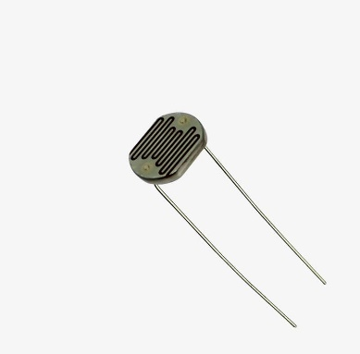

**Fig3.2** **LDR Sensor**

**SERVO MOTOR**

DC servo motor consists of a small DC motor, feedback potentiometer, gearbox, motor drive electronic circuit and electronic feedback control loop. It is more or less similar to the normal DC motor. The stator of the motor consists of a cylindrical frame and the magnet is attached to the inside of the frame. A brush is built with an armature coil that supplies the current to the commutator. At the back of the shaft, a detector is built into the rotor in order to detect the rotation speed. With this construction, it is simple to design a controller using simple circuitry because the torque is proportional to the amount of current flow through the armature.

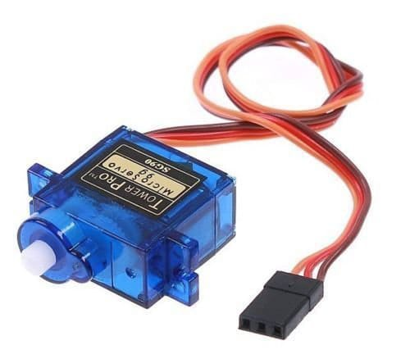

**Fig3.3 Servo Motor**

**Arduino Uno**

Arduino uno board has 6 ADC input ports. Among those any one or all of them can be used as inputs for Analog voltage. The **Arduino Uno ADC** is of 10-bit resolution (so the integer values from (0-(2^10) 1023)). This means that it will map input voltages between 0 and 5 volts into integer values between 0 and 1023. So, for every (5/1024= 4.9mV) per unit. The UNO ADC channels have a default reference value of 5V. This means we can give a maximum input voltage of 5V for ADC conversion at any input channel. Since some sensors provide voltages from 0-2.5V, with a 5V reference we get lesser accuracy, so we have a instruction that enables us to change this reference value.

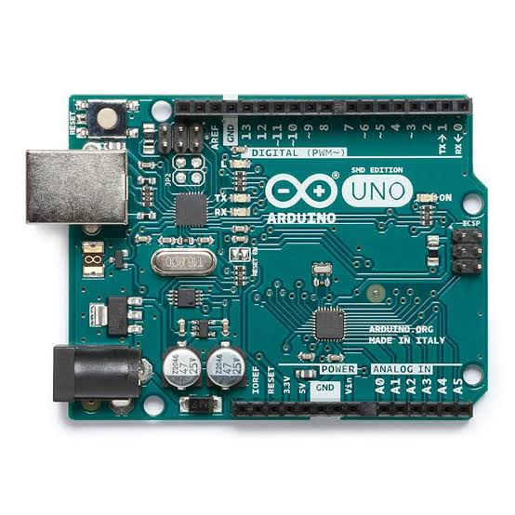

**Fig3.4 Arduino Uno**

**SOLAR PANELS**

Solar panels generate electricity through the photovoltaic effect. When sunlight hits the solar cells within a panel, it excites electrons, allowing them to flow and create an electric current. This direct current (DC) is then converted into alternating current (AC) by an inverter for use in homes or the electrical grid. The efficiency of this process depends on factors like sunlight intensity, angle of incidence, and the quality of the solar cells.

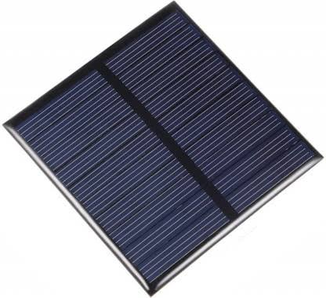

**Fig3.5 Solar Panel**

**LED**

LED stands for Light Emitting Diode. LEDs work by passing a current through a semiconductor material, which emits light when electrons recombine with electron holes. This process is more energy-efficient than traditional incandescent bulbs, making LEDs a popular choice for lighting due to their durability and energy efficiency.

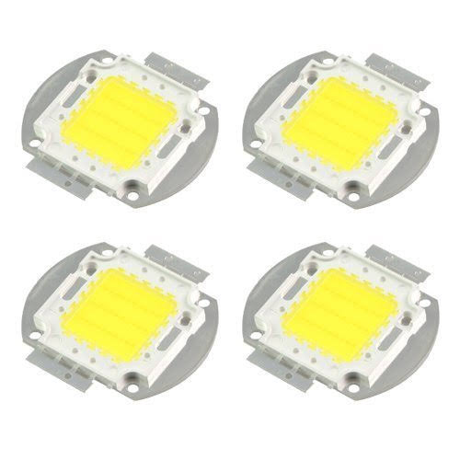

**Fig3.6 LED**

**3.3 COST ESTIMATION**

**Table 3.1 COST ESTIMATION**

|  |  |  |  |
| --- | --- | --- | --- |
| **S.NO** | **COMPONENT** | **QUANTITY** | **COST** |
| 01 | Solar panels | 4 | 400 |
| 02 | Arduino uno(R3) | 1 | 600 |
| 03 | 3d dual axis model | 1 | 400 |
| 04 | Recycle batteries | 2 | 300 |
| 05 | Servo motor | 1 | 200 |
| 04 | Charge controller | 1 | 100 |
| 06 | Other components |  | 500 |
|  |  | **Total** | 2500 |

**CHAPTER 4**

**FUTURE SCOPE & ITS IMPLEMENTATION PLAN**

1. Advanced Sensor Technologies:

Integrate more advanced sensor technologies, such as computer vision or AI-based algorithms, to enhance the accuracy of solar tracking. This can enable the system to adapt to complex weather conditions and shading effects.

2. IoT Integration:

Implement Internet of Things (IoT) connectivity to enable remote monitoring and control of dual-axis solar trackers. This facilitates real-time data analysis, predictive maintenance, and performance optimization.

3. Energy Storage Integration:

Explore integration with energy storage solutions, such as batteries, to store excess energy generated during peak sunlight hours. This can improve energy utilization and provide power during periods of low sunlight or during the night.

4.Dual-Axis Solar Tracking for Concentrated Solar Power (CSP):

Adapt dual-axis solar tracking technology for use in Concentrated Solar Power systems, where precise alignment of mirrors or lenses is crucial for concentrating sunlight onto a receiver to generate heat.

5. Hybrid Systems:

Investigate the integration of dual-axis solar trackers with other renewable energy sources, such as wind or micro-hydro systems, to create hybrid power generation systems that can provide a more stable and reliable energy output.

6. Machine Learning Algorithms:

Implement machine learning algorithms to continuously analyze historical data, weather patterns, and energy production to optimize the solar tracking strategy. This adaptive approach can improve efficiency in varying environmental conditions.

**Implementation Plan:**

1. Research and Development:

Allocate resources for ongoing research and development to stay abreast of advancements in solar tracking technologies, sensor technologies, and control algorithms.

2. Collaboration with Technology Partners:

Collaborate with technology partners, research institutions, and industry experts to leverage expertise and stay informed about emerging technologies in solar tracking and renewable energy.

3. Pilot Projects and Testing:

Conduct pilot projects to test and validate new features or technologies in real-world scenarios. This testing phase helps identify any challenges and ensures the reliability and efficiency of the dual-axis solar tracker system.

4. Regulatory Compliance:

Stay updated on energy regulations and standards to ensure that the implementation of dual-axis solar trackers complies with industry and environmental regulations.

5. User Education and Training:

Develop educational materials and training programs for end-users, installers, and maintenance personnel to ensure the proper installation, operation, and maintenance of dual-axis solar tracker systems.

6. Continuous Improvement:

Establish a feedback loop to gather insights from installed systems, customer feedback, and field performance. Use this information for continuous improvement and updates to future versions of the dual-axis solar tracker.

7. Market Expansion:

Strategically plan for market expansion by identifying regions with high solar potential and increasing awareness about the benefits of dual-axis solar tracking systems. This involves marketing initiatives, partnerships, and targeted outreach programs.

8. Cost Reduction Strategies:

Investigate strategies to reduce the overall cost of dual-axis solar tracker systems, making them more accessible to a wider range of users. This may involve optimizing manufacturing processes, sourcing materials efficiently, and exploring economies of scale.

**Implementation Photos**

**Fig5.1**

**Fig5.2**

**Fig5.3 Geotag photos.**

**Implementation Video Link**

[**https://drive.google.com/file/d/1aEx1eWg-TJl-oxEkLJlkjaDVEx2KJXYK/view?usp=drive_link**](https://drive.google.com/file/d/1aEx1eWg-TJl-oxEkLJlkjaDVEx2KJXYK/view?usp=drive_link)

**Project Working Video Link**

[**https://drive.google.com/file/d/1aGHi7FGdl35ePinN-y-oRJU4gnRFSZCt/view?usp=drive_link**](https://drive.google.com/file/d/1aGHi7FGdl35ePinN-y-oRJU4gnRFSZCt/view?usp=drive_link)

**REFERENCES**

1. D Venkatakrishnan, E Siva Sai, K Sree Hari, “Improved Structure of Automatic solar tracking system”, IJESRT, July,2015.
2. K P J Pradeep, K Sai Prasad Reddy, C Chandra Mouli, K Nagabhushan Raju, “Development of Dual-Axis Solar Tracking using Arduino with LabVIEW”, Vol-17, No. 7, IJETT, November 2014.
3. David Barlev, Ruxandra Vidu, “Innovation in concentrated solar power”, Vol. 95, Issue 10, Pg. 2703-2725, October 2011.
4. Hossein Mousazadeh, Alireza Kayani, “A review of principle and sun-tracking methods for maximizing solar systems output”, Vol.13, Issue 8, Pg. 1800-1818, October 2009.
5. Divya Gnanathangam, Sundara Murthy, Amitabh Wahi, “Design and Implementation of a Dual Axis Solar Tracking System”, Vol. 3, Issue 10, IJRASET, October 2015.
6. Arduino Programming Book. Author, *Brian W. Evans*
7. **SUNFLOWER TYPE SOLAR TRACKING SYSTEM:**

<https://iotprojectsideas.com/dual-axis-solar-tracker-arduino-project-using-ldr-servo-motors/>.

1. **AUTOMATIC NIGHT LIGHT CIRCUIT:**

<https://youtube.com/shorts/iEaHEzah4T4?si=dvSnNXDRMn2mJ9Hh>